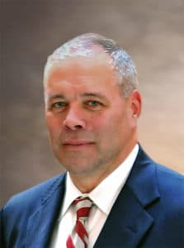

Scott Semple was appointed commissioner of the Connecticut Department of Correction in March 2015. Scott joined the Connecticut Department of Correction as a front line Correction Officer in 1988 at the high security Cheshire Correctional Institution. During his tenure, he has served the agency in numerous administrative capacities, to include pre-service training coordinator, external and legislative affairs, and warden of the state’s only correctional facility dedicated for men requiring comprehensive treatment services for significant mental illness. As commissioner, Scott has successfully implemented several performance based and progressive correctional practices designed to support both staff and incarcerated people. Most notable, they include the Emerging Adult Units known as the TRUE Unit (located in Cheshire) and the WORTH Unit (located in Niantic). He has also repurposed an existing correctional facility and other specific housing units for specialized populations to provide a therapeutic environment designed to support community reintegration. Scott has implemented numerous agency-wide staff wellness initiatives to support, respond and improve policies evolving around the complex and unique needs associated with the health and welfare of correctional professionals and their families. On January 1, 2019, after more than 30-years of service to the agency, Scott retired from public service. He now provides professional consult through Semple Consulting, LLC on various criminal justice and correctional related endeavors. Specifically, Scott serves as a Senior Expert for Falcon Inc., a well-respected consulting entity for correctional and community services.

